Contents

1.0 Introduction 1

2.0 Data structure 2

3.0 Input and Output 5

# 1.0 Introduction

The aim of the project is to develop a prototype system for retail stores of clothing for BuyMe Inc. For development, Visual Studio and the C ++ programming language were used. Also, by condition, doubly linked list was used. For to be able to navigate in both directions according to the data.

# 2.0 Data structure

In the project, there are 4 doubly linked lists’, each of them for different purposes. In addition, all this lists’ have a relationship with each other. The system already has fixed data, but the user can also add their own data.

Figure 1 Example of fixed data

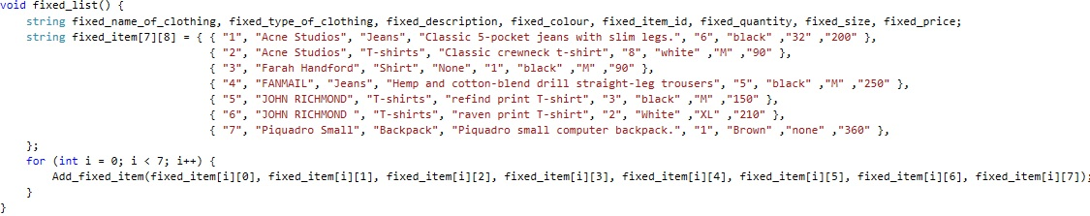

Example declaration of the doubly linked list. Each parameter is assigned a data type. At the end of the declaration, pointers are assigned for future data navigation.

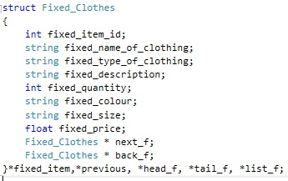

Figure 2 Doubly linked list

On the Figure below example of code which adds nodes to list. To do this, each variable is assigned a value from the linked list. After that, there is a check if the sheet is empty then this value will be assigned to the value of the head. Otherwise, there will be a shift to one node.

Figure 3 Code which adding a data.

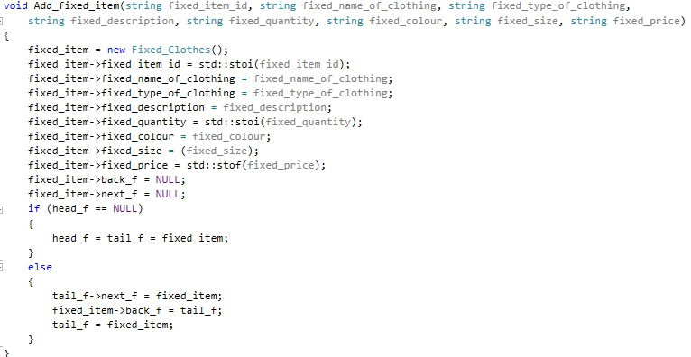

A keyword is used to search for data. The search process itself is obtained this way. First, the user enters the keyword, then the system listens for each record in the worksheet, and at the same time compares the given pointer with the keyword. When the system finds matches, it outputs the entire node.

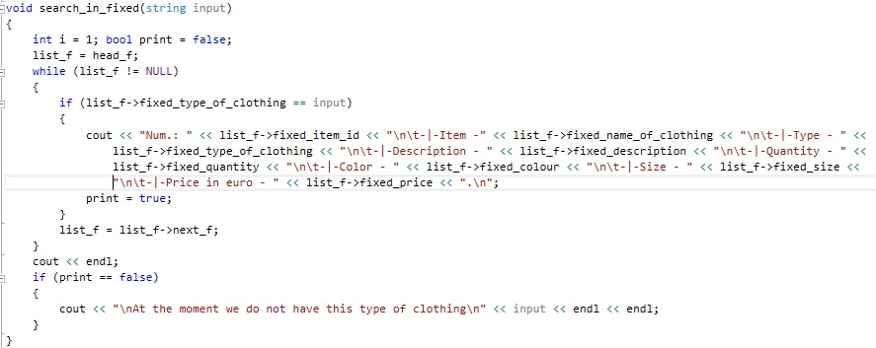

Figure 4 Code that was used for searching

# 3.0 Input and Output

The first thing that is displayed on the screen is the main menu, with three points. First one “*Place an order*” where customers could make orders. Second “*View orders*” in mostly for managing of the orders and third is an “*Exit*”.

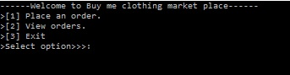

Figure 5 Main menu

If user select “*Place an order*” system will have displayed next 7 function for user. First one, “*Add clothing*” which give opportunity to add items to store. Second, function for displaying

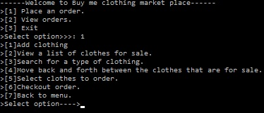

Figure 6 Place and order menu

To add new item to the store, need to enter name of this item, select type, enter description, quantity, color, size and price, Id will be generated automatically.

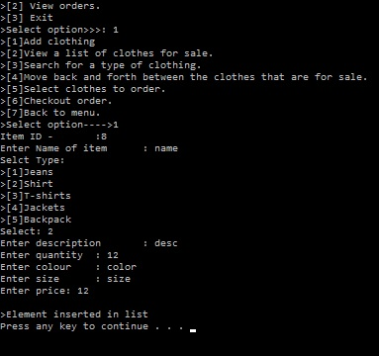

Figure 7 Add new item

Displays all available products. They are separated, new ones are added to the manual, and the rest are fixed in the system.

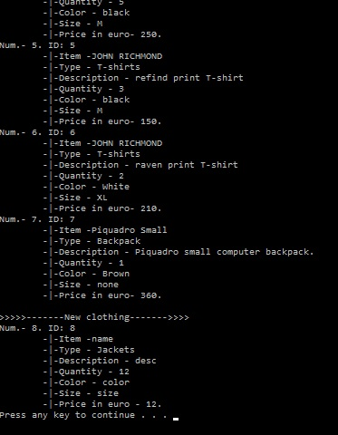

Figure 8 List of all item

To search by type, you just need to enter the type of product, the system will automatically find and output all products of this type.

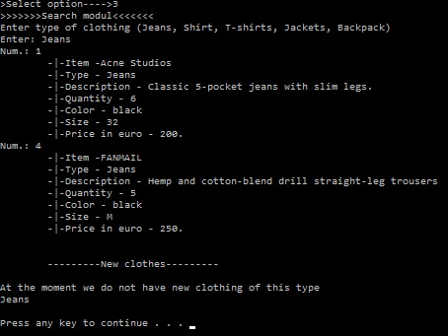

Figure 9 Searching

Fourth function of “Place and order” allow users to move between items in the store.

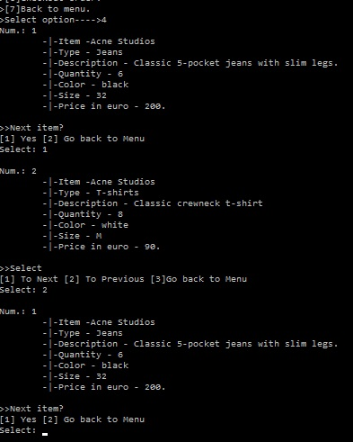

Figure 10 Move between items

Fifth function of “*Place an order”* module allow user to move between items and checkout necessary, after that the goods will be moved to the section checkout.

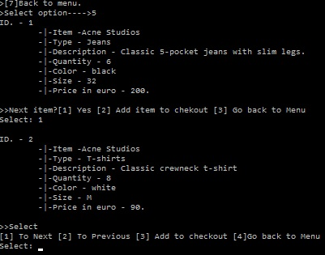

Figure 11 Select for order

On the checkout module, system will be displayed all items that was selected for order. After user select yes, system will display each item separately for ordering and payment. In addition, system displayed total amount for paying.

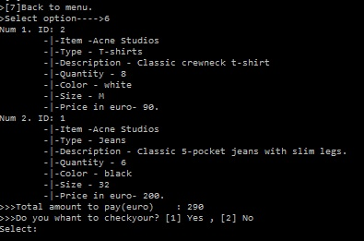

Figure 12 Check out module

After user selected an item for order, system will ask his\her name, address, and phone number. Delivery will cost additional 50RM.

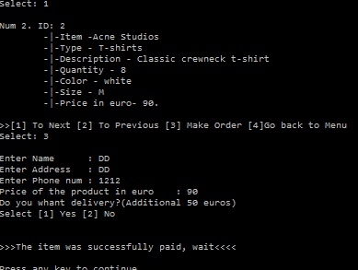

Figure 13 Registration of order

If user selected “*view orders”* in main menu, he\she could view their orders, moving between them and delete order. First function “*view orders*” will display all orders which he made.

